**Java Lab Assignment-2**

Web Server Installation

STEP1: INSTALL APACHE TOMCAT FROM THEIR OFFICIAL SITE

STEP2: INSTALL THE NECESSARY DEPENDENCIES (JDK AND JRE)

STEP3: START THE TOMCAT FROM THE BIN FOLDER IN CMD USING COMMAND: startup

STEP4: THIS WILL HOST THE TOMCAT DEFAULT PAGE IN THE PORT 8080

Tomcat Server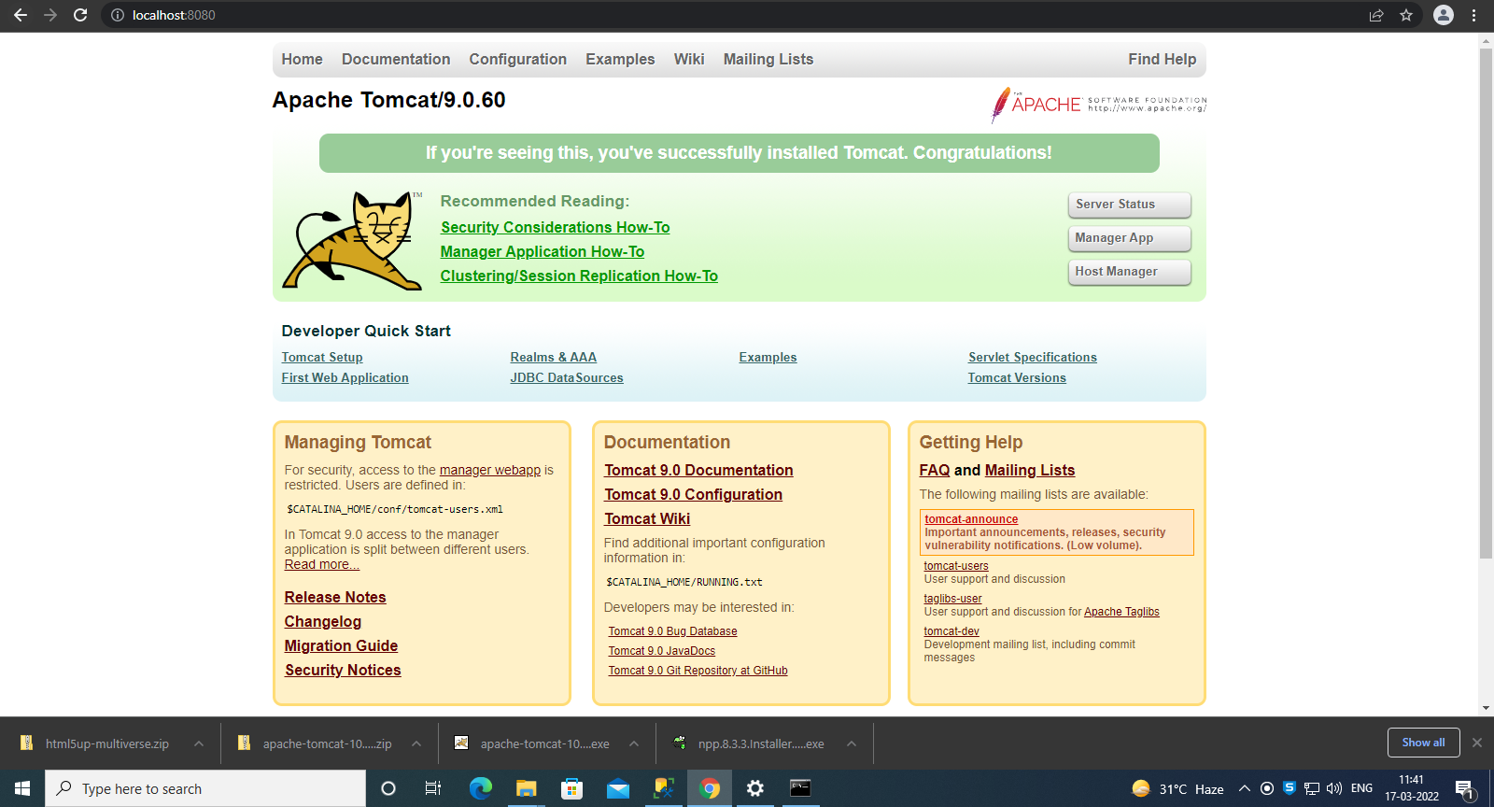

Static website in my Pc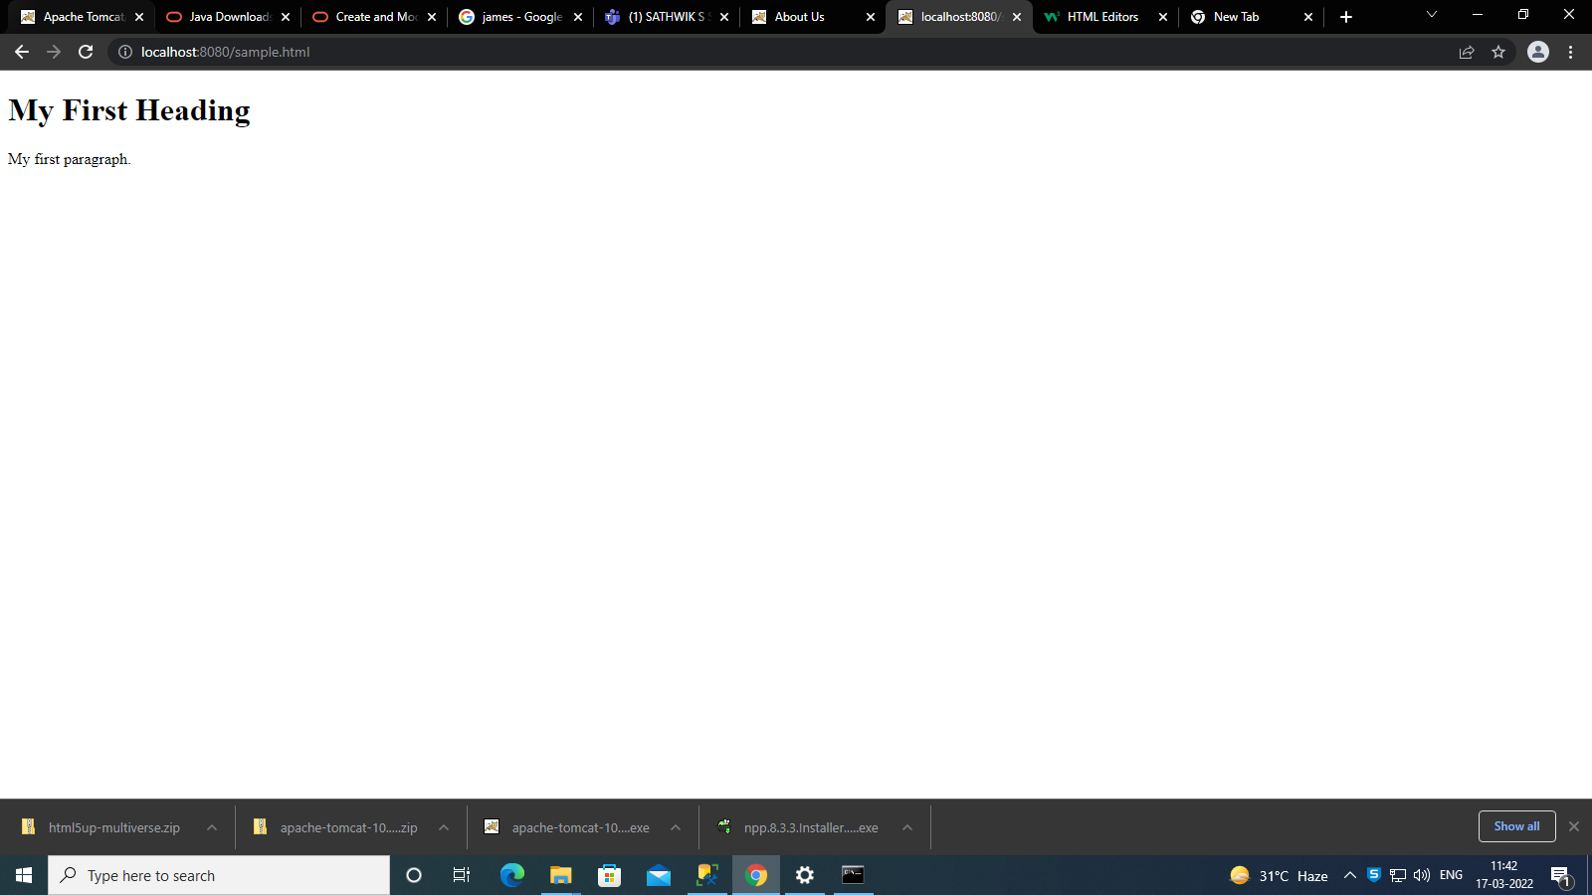

Static website in other pc

